Sales Analytics ETL Project

1. Project Overview
This project implements an end-to-end ETL (Extract, Transform, Load) pipeline using Apache Airflow and Azure services, followed by analytical visualization in Power BI.
The objective is to simulate a real-world data engineering workflow where raw sales data is ingested, cleaned, transformed, stored in a relational database / data warehouse, and finally analyzed through dashboards.

2. Architecture Overview
High-level flow:
- Data Source – CSV files stored in Azure Blob Storage
- Orchestration – Apache Airflow
- Transformations – Python (Pandas)
- Data Warehouse / Storage – Azure SQL Database
- Analytics & Visualization – Power BI
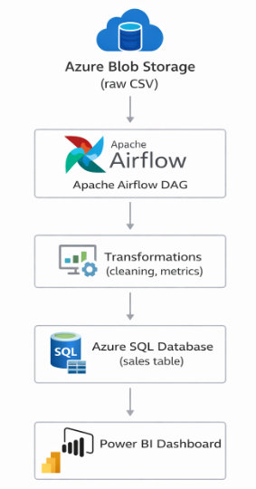
3. Technology Stack
Layer | Technology
Orchestration | Apache Airflow
Programming | Python 3.10
Storage (Raw) | Azure Blob Storage
Database | Azure SQL Database
Analytics | Power BI
OS | WSL (Ubuntu)

4. Data Description
Raw Data (CSV)
Column | Description
order_id | Unique order identifier
product | Product name
category | Product category
quantity | Number of items ordered
price | Price per unit
order_date | Order date

5. ETL Design
5.1 Extract
- Source: Azure Blob Storage container (raw)
- Format: CSV
- Airflow task reads data using Python SDK / Pandas
Purpose:
- Bring raw data into the pipeline without modification

5.2 Transform
Transformations applied:
- Remove rows with null values
- Remove invalid records:
  - quantity ≤ 0
  - price ≤ 0
- Create derived metrics:
  - revenue = quantity * price
- Standardize column types
- Add analytical attributes:
  - Order Value Category (Low / Medium / High)
These transformations ensure data quality and analytics readiness.

5.3 Load
- Target: Azure SQL Database
- Table: sales
- Mode: Append (supports incremental loads)
Purpose:
- Store clean, structured data for reporting and BI tools

6. Apache Airflow DAG Design
DAG Name
etl_sales_pipeline
Tasks
- extract_task
  - Reads CSV from Blob Storage
  - Writes raw file locally (temporary staging)
- transform_task
  - Cleans and enriches data
  - Produces final dataset
- load_task
  - Inserts data into Azure SQL Database
DAG Properties
- Schedule: Daily
- Catchup: Disabled
- Idempotent logic supported

7. Data Model (Current)
Sales Table
Column | Type
order_id | INT
product | VARCHAR
category | VARCHAR
quantity | INT
price | FLOAT
revenue | FLOAT
order_date | DATE
order_value_category | VARCHAR
Note: A star schema (fact + dimensions) can be added later when scaling analytics.

8. Incremental Data Strategy
- New CSV files uploaded to Blob Storage
- Airflow DAG scheduled to run daily
- Logic ensures only new records are inserted
- No manual intervention required
This simulates production-grade automation.

9. Power BI Integration
Connection
- Source: Azure SQL Database
- Authentication: SQL Authentication
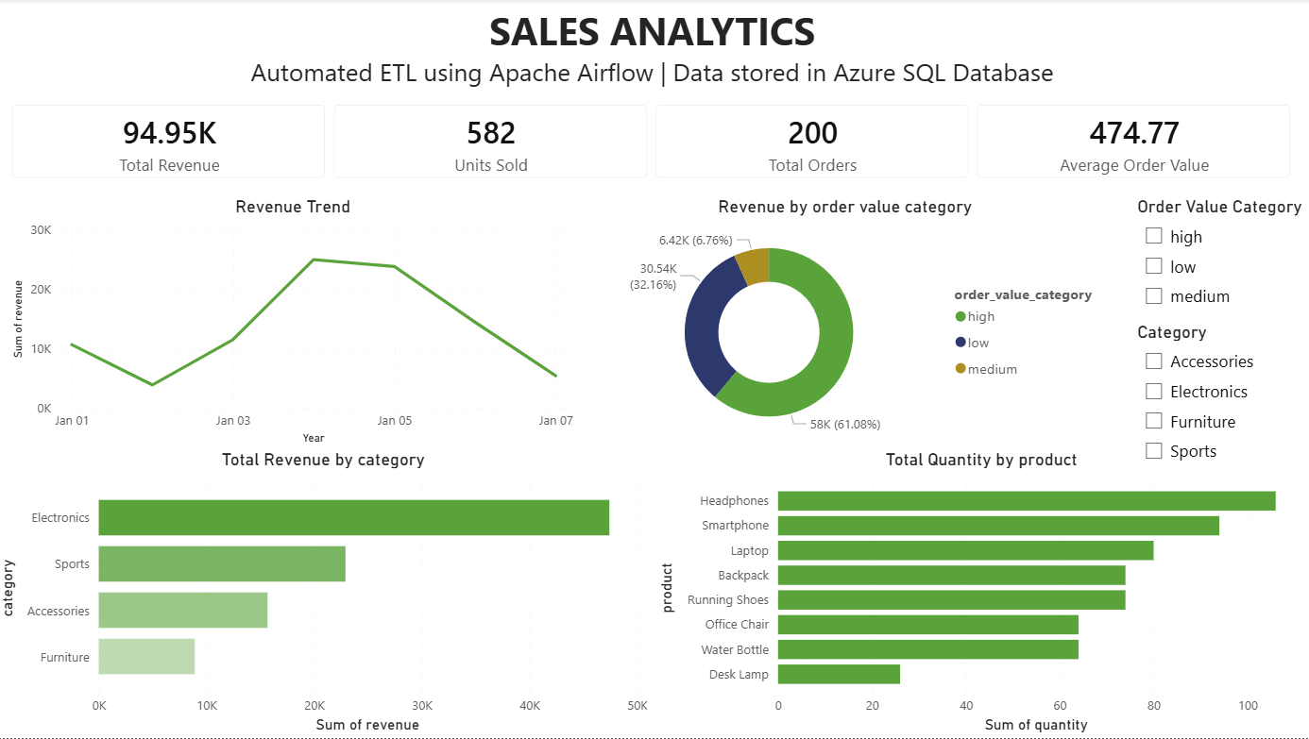
KPIs
- Total Revenue
- Total Orders
- Total Quantity
- Average Order Value
Visuals
- Revenue Trend (Line chart)
- Revenue by Category (Bar chart)
- Quantity by Product (Bar chart)
- Revenue by Order Value Category (Donut chart)

11. Dashboard Purpose
The dashboard enables:
- Executive-level insights
- Trend analysis
- Product and category performance evaluation
- Data-driven decision making

12. Future Enhancements
- Star schema (fact_sales + dimensions)
- Incremental loading with watermarking
- Data quality checks
- Alerts on pipeline failure
- CI/CD for DAG deployment
- Azure Synapse Analytics integration
- Azure Data Factory integration

13. Key Learning Outcomes
- End-to-end ETL pipeline design
- Real-world Airflow usage
- Azure cloud integration
- Data modeling fundamentals
- BI dashboard creation

14. Conclusion
This project demonstrates a complete data engineering lifecycle, from raw data ingestion to business intelligence reporting. It reflects industry-aligned practices and provides a strong foundation for advanced analytics and data warehousing projects.

15. Author
Jeswin K Reji
Aspiring Data Scientist
December 2025
jeswinkr7@gmail.com
LinkedIn GitHub

